Pie Menu Widget

Luis F. Cruz and Ivan Kirillov
CS6456 User Interface Software
College of Computing
Georgia Institute of Technology
801 Atlantic Drive, Atlanta, GA 30332
< luiscruz, ikirillov3 >@gatech.edu

ABSTRACT
Each paper should begin with an abstract, followed by a set of keywords, both placed in the left column of the first page under the left half of the title.
ACM Classification: H5.2 [Information interfaces and presentation]: User Interfaces. - Graphical user interfaces.
General terms: Design, Human Factors (Your general terms must be any of the following 16 designated terms: Algorithms, Management, Measurement, Documentation, Performance, Design, Economics, Reliability, Experimentation, Security, Human Factors, Standardization, Languages, Theory, Legal Aspects, Verification)
Keywords: Guides, instructions, formatting

INTRODUCTION
All body text should be in Times Roman 10 point, with 12 points between successive baselines.
The UIST Conference Proceedings represent the final archival records of the conference. As in previous years, we are striving to give the book a single, high quality appearance. To do this, authors must follow some simple guidelines.
In essence, we ask you to make your paper look exactly like this document. You should match the type style, type size, line spacing, indentation, and layout format as closely as you can. In fact, if you received this document online, you can use it as a template. Just replace the text by your text, while keeping the same format. An RTF version of this document is available on the Web from the “Author’s Guide” at the UIST conference home page (http://www.acm.org/uist/).
Use an A4 or 8.5"x11" sheet of paper. Center the image on the page. The whole image of your text should completely fit in a 17.8 cm x 24 cm box (7" by 9 1/4"). Your submitted material will be photographed 1:1 (no reduction) for printing. We have included here recommendations to help you match this sample with the facilities you might have, such as Script, Microsoft Word on Macintosh or PC, MacWrite, or an impact printer.

Keep this space free for the ACM copyright notice.

TITLE AND AUTHORS
The title, author's names and affiliations run across the full width of the page. We also recommend phone number and e-mail address, if available. (See the top of this page for two names with different addresses. If only one address is needed, center all text in the page)
- Title area: 1 column, 5.9 cm (2 1/3") length, 17.8 cm (7") width.
- Title: bold 18 point Helvetica—mixed cases
- Names: italic 12 point Times Roman
- Addresses, Tel, E-Mail: plain 12 point Times Roman
Do not write “first contact” in the proceeding submissions, only on the cover sheet.

FIRST PAGE COPYRIGHT NOTICE
Remember to leave at least 2.54cm (1") of blank space at the bottom of the left column of the first page, as on this page. You must leave this space for the copyright notice on all submissions intended for publication in the proceedings. Please note that all the authors of all accepted submissions will have to sign a copyright release form. Those forms will be sent with the acceptance letters and need to be returned rapidly. We encourage the contact persons of each submission to keep track of their co-authors' locations because they will be responsible for rapidly collecting the signatures.

NUMBER OF PAGES:
Submissions in different categories have different page limits.
Papers: 10 pages maximum
TechNotes: 4 pages maximum

TWO COLUMNS
After the title use a double-column format as shown here. Column width is 8.5 cm, with 0.8 cm between columns (for a total image width equal to 17.8 cm). Total text length should remain between 23.2 and 24 cm (9 1/4") Right margins should be justified, not ragged. Separate each paragraph by a blank line (and do not indent them). Hyphenation is at your own discretion. The two columns of the last page should be of equal length.

SECTIONS
The title of a section should be in Helvetica 9 point bold in all capitals. Notice that the sections, subsections, and subsubsections are not numbered in this document, but you can number them if you want.

Subsections
The title of subsections should be in Helvetica 9 point bold with only the initial letters capitalized. (Note: Words like “the” and “a” are not capitalized unless they start a title.)
Subsubsections. The heading for subsubsections should be in Helvetica 9 point italics with initial letters capitalized. (Note: Words like “the” and “a” are not capitalized unless they start a title.) Here, the heading is not followed by a return.

TYPESET TEXT
Papers should be prepared on a typesetter or word processor. Please do not use your favorite obscure font. We want to produce a book that looks like a book, not like many dissimilar papers thrown together. Please use a 10 point Times Roman font, or other Roman font with serifs, as close as possible in appearance to Times Roman in which these guidelines have been set. The target is to have a 10 point type set on an 11 point line, as you see here. Do not use a sans-serif font (e.g., Helvetica) except for emphasis, headings and the title. The Press 10 point font available to users of Script is a most acceptable substitute for TimesRoman. If actual Times Roman is not available, users might try font ComputerModern Roman. Macintosh users should use the font named Times.
If you do not have a laser printer, try to borrow one, rent one, or make friends with somebody who has one. In some cases you might be able to bring a disk to a business that will print your document for you. If you really cannot use a laser printer send your submission on the best alternative printer you have. As a very last resort, if typesetting facilities are not available, papers can be typewritten on a typewriter. In this case, the text must be prepared on larger pages and then reduced 25%.

FIGURES
Figures must be inserted at the appropriate point in your text (Figure 1). Figures can extend over the two columns up to 17.8 cm (7") if necessary. Black and white photographs (not Polaroid prints) may be mounted on the camera-ready paper with glue or double-sided tape. (Please note that even clear tape mounted over figures or text will cause a noticeable smudge; attach figures only from behind.
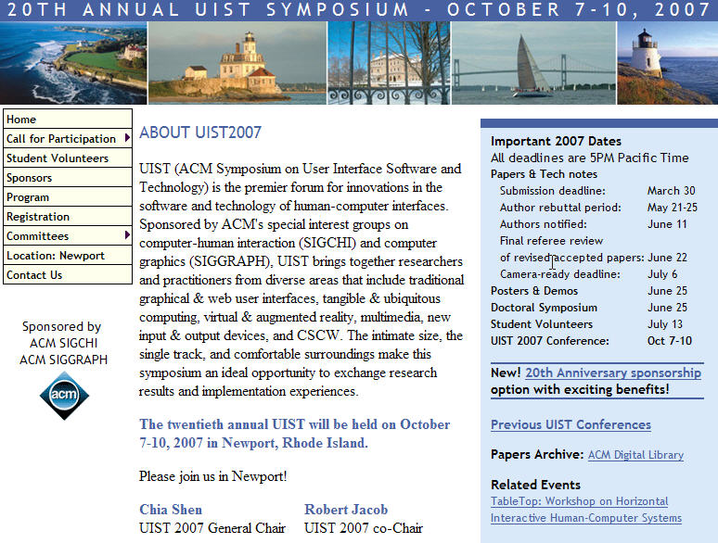
Figure 1: An example of figure caption. It is set in 9 point Helvetica, with a small 0.5cm indentation on both left and right sides.
For better quality you can have stats or screened velox prints that are up to 150 lines per inch prepared by your local printing service. Of course you can do it yourself with a good scanner. Remember that some readers may never see anything other than a poor photocopy of your paper, so make sure that the figure will still be readable (try to see how it looks after recopying it a couple of times).

REFERENCES AND CITATIONS
Use the standard CACM format for references, i.e., a numbered list at the end of the article, ordered alphabetically by first author, and referenced by number in brackets [2]. (See the examples of citations at the end of this section or other examples in the April 94 issue of the Communications of the ACM, p. 12). References should be materials accessible to the public (i.e., articles in standard journals and open conference proceedings.) Internal technical reports should be avoided unless easily accessible (i.e., you can give the address to obtain it). Private communications should be acknowledged, not referenced.

HEADERS, FOOTERS AND PAGE NUMBERING
Do not use headers, footers or footnotes. Page numbers, footers and headers will be added when the Conference Proceedings are assembled. Papers submitted to the paper chairs for review should have page numbers (to help the review process).

OTHER CONSIDERATIONS

No Private Material
Presentations may not contain any proprietary or confidential material. Please clear all materials before submitting or presenting them. Submission of pictures of identifiable people should be done only with the understanding that responsibility for collection of appropriate permissions rests with the submitter.

Equations
Displayed equations should be centered, with optional equation numbers right-justified to the right margin of the column.

Spelling
Spelling may follow any dialect of English (e.g., British, Canadian, or American), but please use it consistently.

Language
The language of UIST '96 is English for an international audience. Avoid puns and slang. English will not be the mother tongue of many readers (and reviewers). Today, part of striking the right tone is also handling gender-linked terms sensitively. Avoid gender specific expressions when unnecessary. But also try to avoid the awkward he/she or her/his. Consider the plural or replace third person singular possessives with articles (e.g. “a” rather than “his”). Occasionally, passive forms can be used.

ACKNOWLEDGMENTS
The authors would like to acknowledge the contributions of many previous editors in the writing and formatting of this document. This document is based on the CHI '94 formatting guidelines.

REFERENCES
- Cole, William G.Understanding Bayesian Reasoning Via Graphical Displays. In Proceedings of CHI'89 Human Factors in Computing Systems (April 30–May 4, Austin, TX), ACM/SIGCHI, NY, 1989, pp. 381–386.
- Gary, M.R. Optimal binary identification procedures. SIAM J. Appl. Math. 23, 2 (Feb. 1972), 173–186.
- Garey, M.R. and Johnson, D.S. Computers and Intractability: A Guide to the Theory of NP- Completeness. Freeman, San Francisco, CA, 1979.

